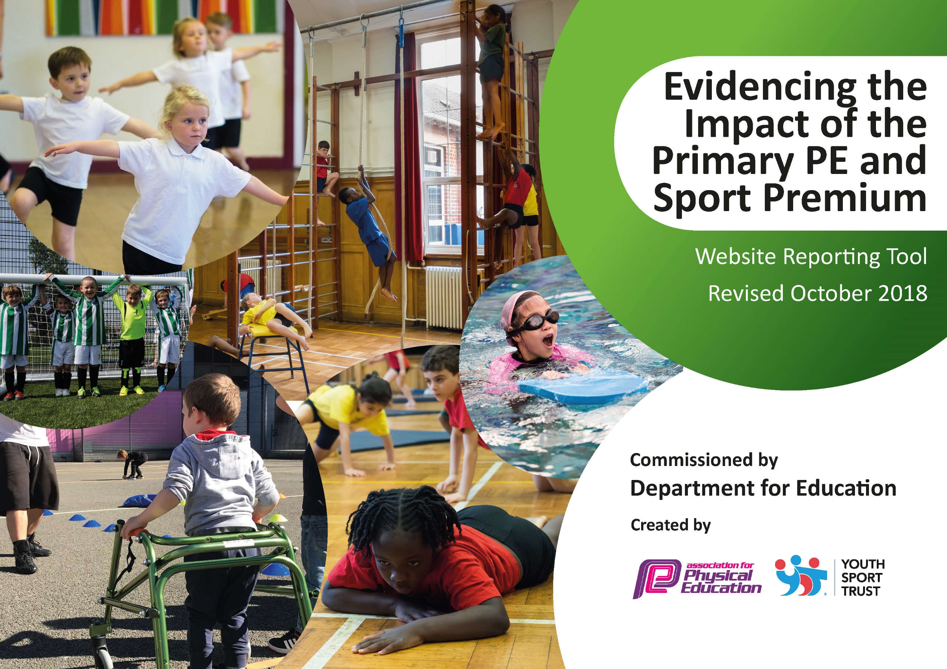
Key achievements to date: | Areas for further improvement and baseline evidence of need:
- School have appointed new PE Lead and PE Specialist Full time.  - School Continue to monitor Holly water Mile.  - New PE Equipment and resources have been purchased.  - Sports Trips arranged for our students to visit another school to participate in different sport Lessons being delivered by Highfield Staff.  - Rebound therapy lessons being delivered weekly by qualified Rebound Therapy coach.  - Students accessing swimming lessons off site.  - Yoga Teacher visiting weekly to deliver Yoga sessions to students.  - Team Rubicon visited school to deliver skateboarding sessions to students. | - Build on feedback from LSAs to ensure active playtimes can be implemented; staff wanted an increase in resources available and to be access more areas of the playground.  - Ensure Key Stage 1 have more physical development opportunities as a result of the PE premium.  - More resources and equipment to help promote active play times and engagement.  - More PE Equipment and resources to be purchased for students.  - Developing links with Sara (School games organiser).

Meeting national curriculum requirements for swimming and water safety | Please complete all of the below:
What percentage of your current Year 6 cohort swim competently, confidently and proficiently over a distance of at least 25 metres?  N.B. Even though your children may swim in another year please report on their attainment on leaving  primary school. | 0%
What percentage of your current Year 6 cohort use a range of strokes effectively [for example, front crawl, backstroke and breaststroke]? | 0%
What percentage of your current Year 6 cohort perform safe self-rescue in different water-based situations? | 0%
Schools can choose to use the Primary PE and Sport Premium to provide additional provision for swimming but this must be for activity over and above the national curriculum requirements. Have you used it in this way? | No

Academic Year: 2025-26 | Total fund allocated: £16,430 | Date Updated: 13/11/2025
Key indicator 1: The engagement of all pupils in regular physical activity – Chief Medical Officer guidelines recommend that primary school children undertake at least 30 minutes of physical activity a day in school |  |  |  | Percentage of total allocation:
 |  |  |  | %
School focus with clarity on intended impact on pupils: | Actions to achieve: | Funding allocated: | Evidence and impact: | Sustainability and suggested next steps:
Continuation of yoga as activity to provide more opportunities for physical activity. | Sessions being led by Yo-Chi instructor with teachers working alongside. (K.I. 1, 4) | £2070 | Yoga sessions took place in Autumn Term and Spring Term to include the high dependency group. They are booked for Summer term. Pupils and staff speak very highly of the sessions and staff report and have observed pupils with SLD engaging well with the lessons and demonstrating increased flexibility and a sense of calm following the session. Elsa, the yoga instructor, ensures her lessons are pitched at the right level for each different group. | Staff have been present during yoga sessions. Yoga sessions will continue where financially viable.  • Yoga was delivered to groups of pupils in the Autumn and Spring term that also included our High Dependency groups as a sensory enrichment activity.  Yoga instructor rebooked for September 25.
Key indicator 2: The profile of PESSPA being raised across the school as a tool for whole school improvement |  |  |  | Percentage of total allocation:
 |  |  |  | %
School focus with clarity on intended impact on pupils: | Actions to achieve: | Funding allocated: | Evidence and impact: | Sustainability and suggested next steps:
Whole school awareness of success in PE.  Rebound Therapy Certificates and badges purchased to celebrate success | Continue to update the noticeboard in the school corridor to celebrate success in PE lessons and offsite activities, regularly updated.  Celebrate sporting/physical achievements in assemblies that have been at home and school.  Celebrate sporting/physical achievements in assemblies that have been at home and school. | £0  £0  £46.83 | Noticeboard continues to be updated. Pupils can see their own and other’s achievements.  Achievements have been celebrated in departmental and whole school assemblies where appropriate.  Achievements will be celebrated in assemblies and certificates and badges to go home. | Noticeboard continue to be updated.  Notice board in main school corridor updated May 2024 to celebrate movement at Holly water.  OH to Update Notice Board.  Continue.  • 5 staff members currently trained to deliver rebound therapy, 1 currently booked onto refresher course.  Rebound therapy sessions continued to be delivered weekly across the school.

Key indicator 3: Increased confidence, knowledge and skills of all staff in teaching PE and sport |  |  |  | Percentage of total allocation:
 |  |  |  | %
School focus with clarity on intended  impact on pupils: | Actions to achieve: | Funding  allocated: | Evidence and impact: | Sustainability and suggested  next steps:
PE Lead attended PE Conference to gain further knowledge.  CPD Sessions delivered to Staff members to upskill their knowledge on teaching PE. | Gain Further Knowledge.  Upskill Holly water staff members knowledge on Teaching PE. | £200  £0 | PE knowledge Increased.  To ensure staff are more confident to deliver PE to our students. | OH Attended PE Conference.  OH to deliver CPD Sessions to upskill Holly water staff knowledge on how to deliver PE.
Key indicator 4: Broader experience of a range of sports and activities offered to all pupils |  |  |  | Percentage of total allocation:
 |  |  |  | %
School focus with clarity on intended  impact on pupils: | Actions to achieve: | Funding  allocated: | Evidence and impact: | Sustainability and suggested  next steps:
Continuation of yoga as activity to provide more opportunities for physical activity.  Dance Teacher to visit Holly water School to deliver Dance workshops to primary Students.  More Resources for outside Areas.  Purchase of moveable outdoor storage containers to increase access to PE resources at playtime, building on feedback from LSA active playtime training. | Yoga instructor still attends Holly water School.  To give students more opportunities to experience different sports.  To improve active play times.  To Ensure equipment gets looked after.. Purchase of outdoor storage containers | £1912  OH Research  £2000  £1000 | Students able to access Yoga sessions.  Students to have more opportunities.  To help increase and improve active play times.  To ensure equipment and resources gets looked after sufficiently without items going missing or getting broken. | Ensure strong link remains with Elsa.  OH to arrange  OH to look and purchase resources for active play.  Resources to be monitored by PE lead and replaced as required. Pupils have been able to access more physical movement across the day.  .  .
Key indicator 5: Increased participation in competitive sport |  |  |  | Percentage of total allocation:
 |  |  |  | %
School focus with clarity on intended  impact on pupils: | Actions to achieve: | Funding  allocated: | Evidence and impact: | Sustainability and suggested  next steps:
Arrange more offsite sporting events for students to enjoy and participate in. | To give students more opportunities to take part in competitive sporting events to help grow and increase confidence. | £0 | To Increase confidence in competing in different sporting events. | OH to arrange sporting events for Holly water staff to participate in.

